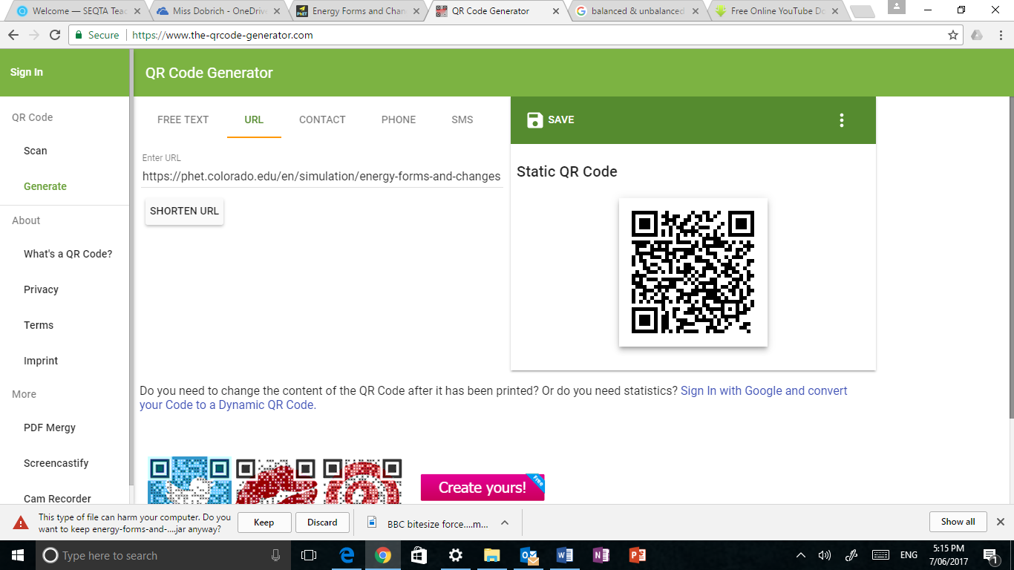**Energy Forms & Changes***PhET Simulation*

**GO TO:** PhET – Energy Forms & Changes  
<https://phet.colorado.edu/en/simulation/energy-forms-and-changes>

In this simulation you will be able to “see” several different forms of energy and the changes (transfers) that can occur between them. You are also able to work with a system where you can manipulate the energy input, observe the process of electrical energy generation and manipulate the output.

**INTRO**

1. Click on the **“Intro” tab**.
2. 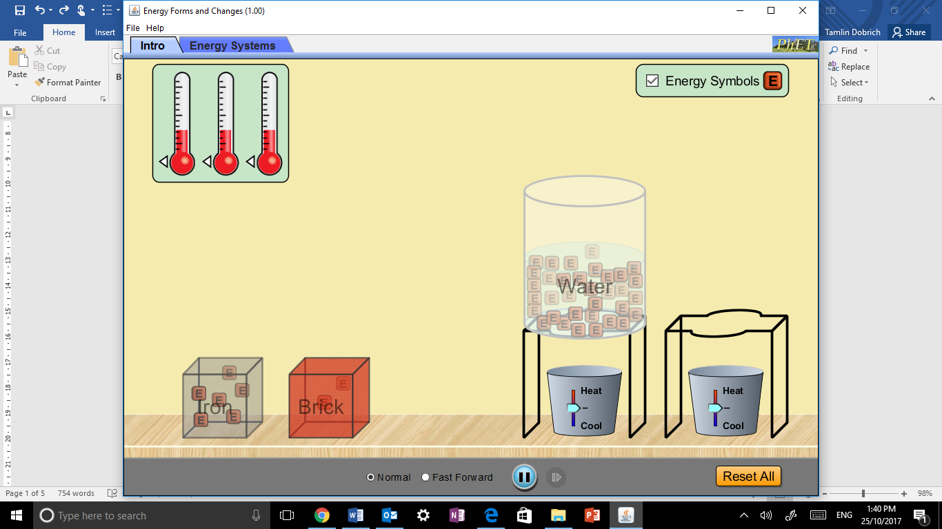Be sure to click the **“Energy Symbols” box** so the different types of energy will be visible throughout the process.

**INVESTIGATION QUESTIONS**

1. Drag the water container over the temperature controller as shown 🡪

Compare how “energy” moves in water at high temperatures with that of low temperature.

|  |
| --- |
|  |
|  |
|  |

1. In which direction does the energy move as it heat up? ____________________
2. Propose a reason why it moves in this direction.

|  |
| --- |
|  |
|  |

1. 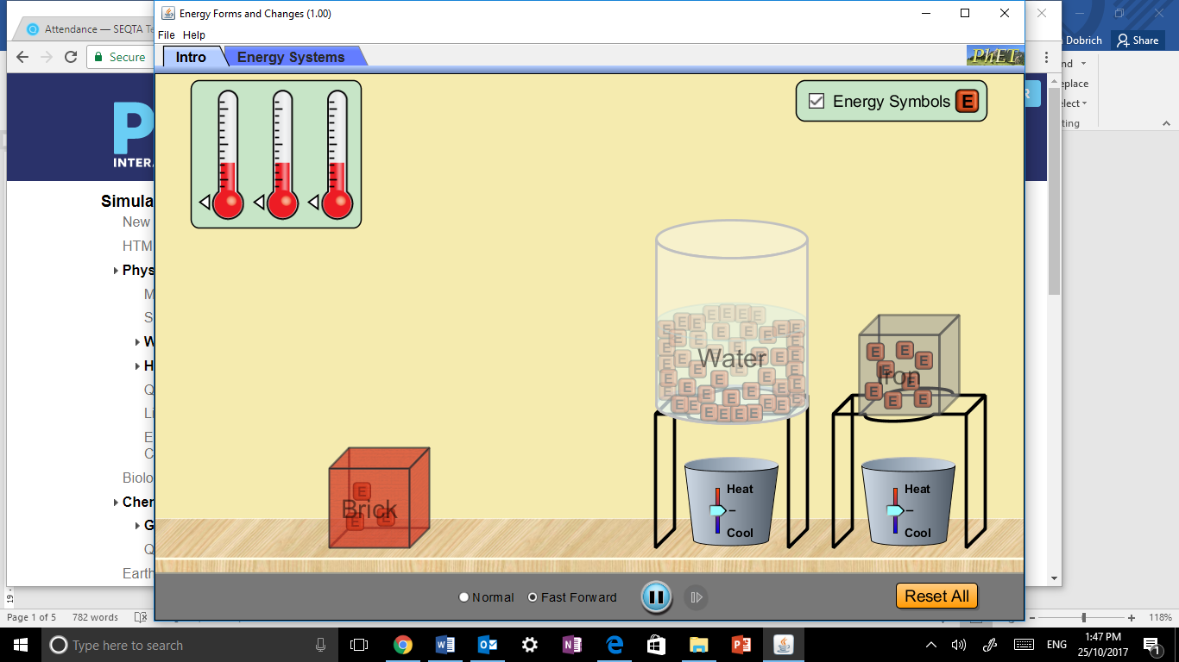Drag the iron block over the other temperature controller 🡪

Compare how water and iron transfer “energy”.

|  |
| --- |
|  |
|  |
|  |

**ENERGY SYSTEMS**

1. Click on the **“Energy Systems” tab**.
2. Be sure to click the **“Energy Symbols” box** so the different types of energy will be visible throughout the process.

**GETTING FAMILIAR WITH THE OPTIONS**

Experiment with the different source, generation and output options – there are many combinations to play with – then complete the questions below.

|  |  |  |  |  |  |  |  |  |  |
| --- | --- | --- | --- | --- | --- | --- | --- | --- | --- |
| **Energy Input Options** | | | | **Energy Generators** | | **Energy Output Options** | | | |
|  |  |  |  |  |  |  |  |  |  |
| **Faucet** | **Sun** | **Kettle** | **Bike** | **Turbine** | **Solar Panel** | **Water Heater** | **Regular Bulb** | **Fluorescent Bulb** | **Fan** |

1. Which **energy sources (input)** can cause the turbine (wooden wheel) to spin and generate electrical energy?

|  |
| --- |
|  |
|  |

1. Which **energy sources (input)** can cause the solar panels to generate electrical energy?

|  |
| --- |
|  |
|  |

1. Which **energy output** objects work with the turbine?

|  |
| --- |
|  |
|  |

1. Which **energy output** objects work with the solar panels?

|  |
| --- |
|  |
|  |

1. What happens to the amount of electrical energy that is generated when the…  
   1. Faucet is on high: ________________________________
   2. Faucet is on low: ________________________________
   3. There are no clouds: ________________________________
   4. There are lots of clouds: ________________________________
   5. Low heat on the kettle: ________________________________
   6. High heat on the kettle: ________________________________
   7. The girl pedals slowly: ________________________________
   8. The girl pedals quickly: ________________________________
2. Explain why the cyclist must be fed in order to continue to pedal.

|  |
| --- |
|  |
|  |

1. The Law of conservation of energy stated that _______________________________________________________________

|  |
| --- |
|  |

**EXPLORING ENERGY TRANSFER**

Set up your system as shown in the picture. Let it run for a while and then complete the sentences using the energy symbols to help you “see” the flow of energy within each system.

**ACTIVITY 1: Turbine moved by medium water flow from faucet with a hot water system**

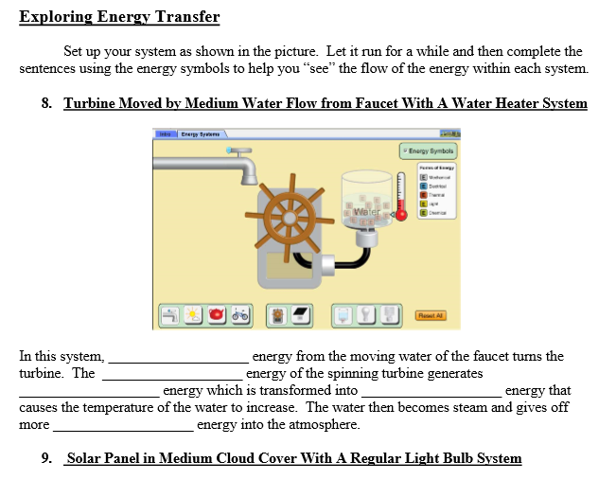

In this system _______________________ energy from the moving water of the faucet turns the turbine. The ______________________ energy of the spinning turbine generates _______________________ energy which is transformed into ________________________ energy that causes the temperature of the water to increase. The water then becomes steam and gives off more ________________________ energy into the atmosphere.

**ACTIVITY 2: Solar panel in medium cloud cover with a regular light bulb system.**

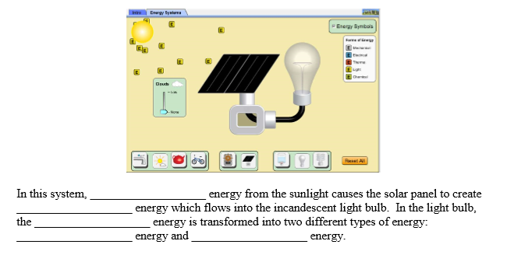

In this system, ___________________ energy from the sunlight causes the solar panel to create _________________ energy which flows into the incandescent light bulb. In the light bulb, the _________________ energy in transformed into two different types of energy: ____________________ energy and ___________________ energy.

**ACTIVITY 3: Turbine moved by steam from medium heat kettle with a water heater system.**

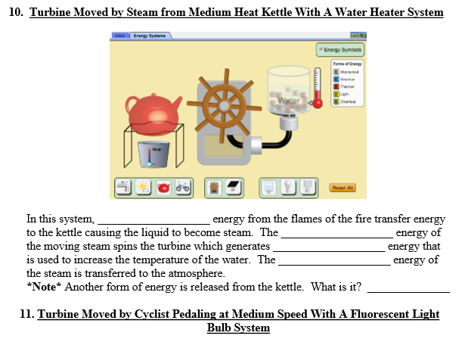

In this system, __________________ energy from the flames of the fire transfer energy to the kettle causing the liquid to become steam. The ___________________ energy of the moving steam spins the turbine which generate _______________________ energy that is used to increase the temperature of the water. The ___________________ energy of the steam is transferred to the atmosphere.

**NOTE:** another form of energy is release from the kettle. What is it? ______________________________

**ACTIVITY 4: Turbine moved by cyclist pedalling at medium speed with a fluorescent light bulb system.**

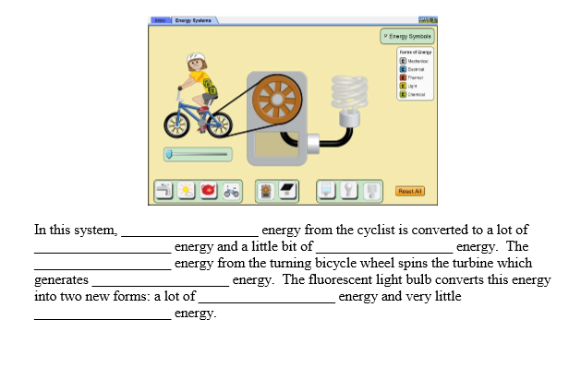

In this system, _________________ energy from the cyclist is converted to a lot of __________________ energy and little bit of ___________________ energy. The ___________________ energy from the turning bicycle wheel spins the turbine which generates ____________________ energy. The fluorescent light bulb converts this energy into two new forms: a lot of ____________________ energy and very little __________________ energy.

**ACTIVITY 5: Investigation questions**

1. Switch out the fluorescent bulb with the regular bulb and observe the energy output. What do you notice about the difference in energy and output of these two bulbs?

|  |
| --- |
|  |
|  |

1. In your opinion, which light bulb is more efficient? _______________________________________________
2. How do you know this? _____________________________________________________________________
3. What common form of energy (not including kinetic or potential) is not included in the “Energy Symbols” key that would normally be present in these examples?   
     
   ____________________________________
4. Look carefully at each of the four systems shown above. Knowing what we have discussed about energy conversion, identify (list) at least three different places where this form of energy (question 2) should be “produced”.

|  |
| --- |
|  |
|  |

1. In the space below, explain why this simulation is a good way to illustrate the Law of Conservation of Energy. Use specific examples to support your answer.

|  |
| --- |
|  |
|  |
|  |
|  |
|  |